

Simulating Natural Selection

Joakim Hertzberg, Gabriel Torres, Max Warstrand

TABLE OF CONTENTS

1: INTRODUCTION

1.1: BACKGROUND 2

1.2: THEORY 2

1.3: QUESTION & AIM 2

1.4: HYPOTHESIS 2

1.5: NULL HYPOTHESIS 2

2: METHOD

2.1: Materials 3

[**3: RESULTS**   
 3.1: Figures 3](#_Toc133494792)

4: DISCUSSION

4.1: ANALYSIS of Results 11

4.2: CONCLUSION 11

4.3: EVALUATION 12

5: SOURCES

# 1: INTRODUCTION

## 1.1: BACKGROUND

The Theory of Natural Selection outlines the basis of population change and evolution. If an individual better adapted to its environment, as a result of genetic mutation, genetic drift etc, will have the greatest odds of reproducing. Therefore it will have the greatest probability of passing those genes on to its offspring, working to secure its position in the genetic pool of the species. In what way an organism is better or worse adapted to its environment is the cause of a myriad of factors, including survival instincts, cognitive function, and appearance. The latter is frequently studied by observing *Biston betularia* – commonly called the peppered moth.

For over 200 years, the global environment has undergone drastic, observable change – both at macro- and micro-level ("Intergovernmental Panel on Climate Change (IPCC).", Environmental Encyclopaedia, 2011). Before the Industrial Revolution, English Peppered Moths were largely observed to be white in color with little to no darkened species on their wings. However, as some places began being polluted with soot, it was observed that individuals residing in an affected habitat were more likely to have wings that were nearly entirely black (**Fig. 1**). Today we recognize this phenomenon as micro-evolution – a shift in allele frequency within a population. Since the black moths were more likely to remain hidden from predators in a blackened environment, the alleles that code for the trait of being black surged. In populations that were affected by this kind of pollution, the black allele became much more frequent in the genetic pool.

### 1.2: THEORY

The appearance of the moth’s body, as well as its wings, is assumed to be a polymorphic and codominant trait. If a moth has inherited two black alleles (WBWB) it is anticipated to be black, whereas two speckled alleles (WSWS) code for a speckled body. If an organism has inherited one black and one speckled allele (WBWS) it codes for the pied trait.

## 1.3: QUESTION & AIM

To simulate and study the effects of predation of three polymorphic populations of moths, living in three different environments. Will the predation of individuals in different environments be selective?

## 1.4: HYPOTHESIS

If an organism has an appearance that is similar to its environment, then its likelihood of surviving a predation session will be greater because other organisms that stand out more, are more likely to be seen instantaneously and hunted by a predator. This will result in an allele shift where the alleles coding for the environmentally corresponding trait will increase in frequency, causing micro-evolution.

## 1.5: NULL HYPOTHESIS

The predation will show results with equal proportion over all populations (see *expected* values in **Fig. 8**, **Fig. 9**, and **Fig 10.**), with a χ2 value not exceeding the critical value of 5.99, hence showing no significant difference.

# 2: METHOD

## 2.1: Materials

* Black A3 paper
* A3 paper with pied texture
* A3 paper with speckled texture
* 5 black paper cut-outs
* 15 paper cut-outs with pied texture
* 15 paper cut-outs with speckled texture
* Four people to act as predators
* A blindfold

## 2.2: Procedure

1. Calculate the allele frequency of WB and WS in the original populations i.e.-of the total sum of alleles, what are the percentages of WB and WS? Calculate the phenotype (morph) frequency in the original populations. How many Black to Speckled to Pied moths in percent?
2. Select one to act out as the fearsome Great tit and then send the predator on a short walk. Non-predators stay and place out a population on a tree bole i.e. the habitat, here represented in the form of A3 paper sheets.
3. Lure the predator to its foraging (feeding) site and let it begin to feed;-Place the Great tit with its back to the tree-bole (here placed on a table).-Given a signal, the tit should quickly turn around and point at the moth that it sees first. This procedure is to be performed quickly!-Remove the chosen moth from the population –it has been swallowed and eaten!-Shuffle around the moths on the paper and repeat this procedure 10times, i.e.”eat” 10 moths. If you miss –go again! Perform the same method of foraging for all three habitats, one at the time. Then repeat it 2 times for each bole type. Switch predator for each feeding time / bole.
4. Record and Pool/ Collect the results.

## 3: RESULTS 3.1: Figures

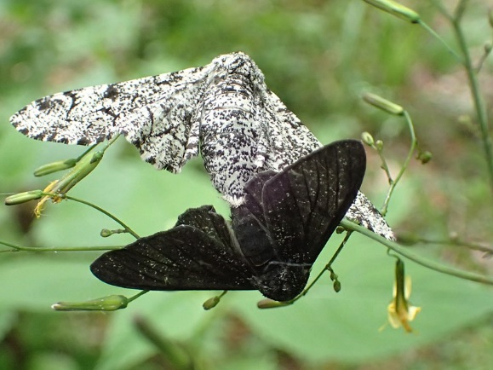

**Figure 1.**Two individuals of the species *Biston Betularia* with different phenotypic expressions.

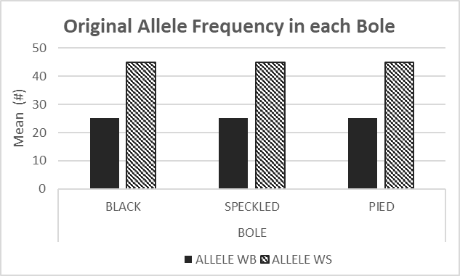

**Figure 2.**This chart illustrates the mean number of black alleles, contra speckled alleles that existed in the original population, for each bole. This data was collected pre-predation.

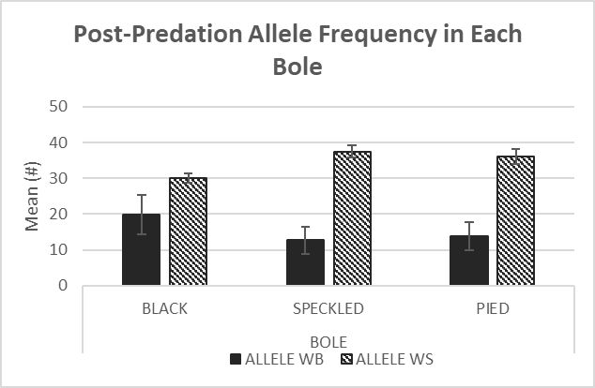

**Figure 3.**This chart illustrates the mean number of black alleles, contra speckled alleles that survived each predating session in the three different boles. The data set includes standard deviation.

**Figure 4.**This chart illustrates the allele percentage of the new population. The percentage is relative to its original allele percentage.

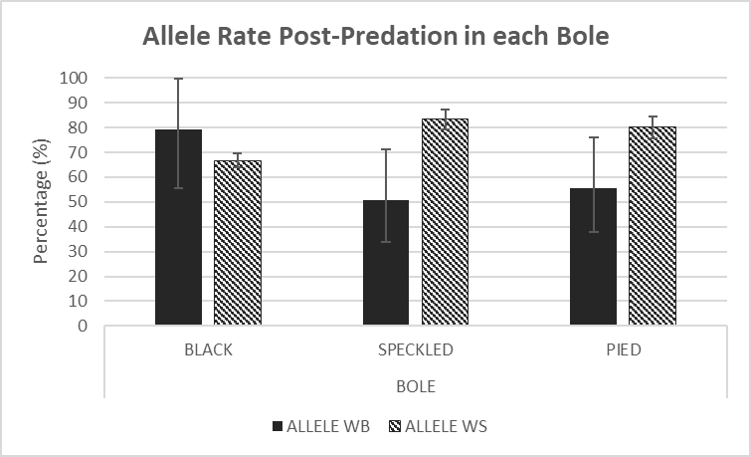

**Figure 5.**This chart illustrates the total allele frequency of the new population in all boles.

**Figure 6.**This chart illustrates the total allele percentage of the new population. The percentage is relative to its original allele percentage.

**Figure 7.**This chart illustrates how the mean number of individuals of each phenotype that survived predation. The data is separated by bole.

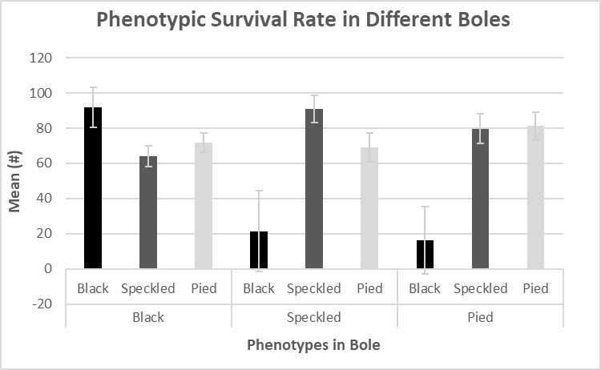

**Figure 8.**This chart illustrates how the mean percentage of individuals of each phenotype that survived predation. The data is separated by bole.

**Figure 9.**This chart illustrates the percentage of each phenotype that survived. The graph combines the data sets from the different boles.

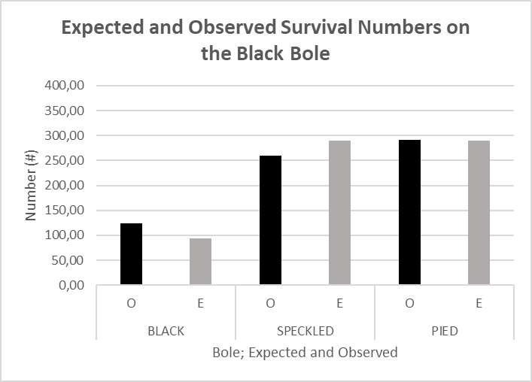

**Figure 10.** This chart shows the number of Observed Moths Survived (O) in comparison to the Expected Moths survived (E), for each phenotype, in the Black Bole

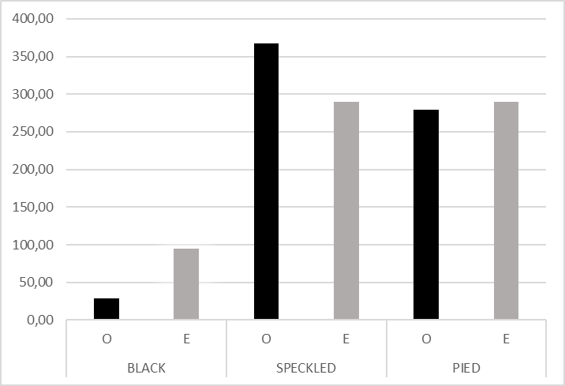

**Figure 11.** This chart shows the number of Observed Moths Survived (O) in comparison to the Expected Moths survived (E), for each phenotype, in the Speckled Bole

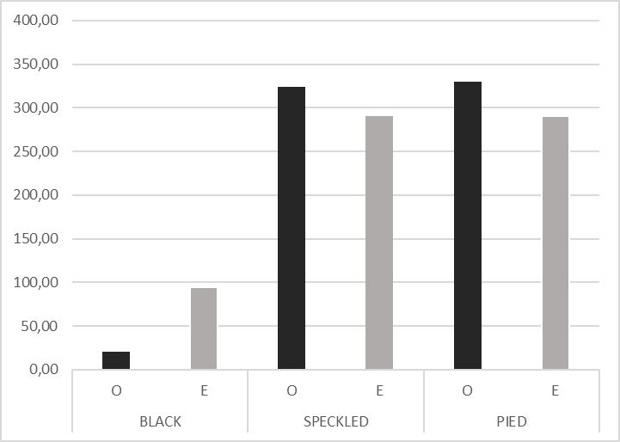

**Figure 12.** This chart shows the number of Observed Moths Survived (O) in comparison to the Expected Moths survived (E), for each phenotype, in the Pied Bole



**Table 1.**This chart shows the number of black, speckled, and pied moths that survived on the Black Bole, per trial and group.



**Table 2.**This chart shows the number of black, speckled, and pied moths that survived on the Speckled Bole, per trial and group.



**Table 3.**This chart shows the number of black, speckled, and pied moths that survived on the Pied Bole, per trial and group.



**Table 4.**   
This table shows the raw percentage data for moths survived in the black bole, separated by phenotype.



**Table 5.**   
This table shows the raw percentage data for moths survived in the speckled bole, separated by phenotype.



**Table 6.**   
This table shows the raw percentage data for moths survived in the pied bole, separated by phenotype.

**Table 7.** Black Allele Frequency  
This table shows the number of black alleles (WB) that survived each predating session for every trial in the three boles.



**Table 8.** Black Allele Frequency  
This table shows the percentage of black alleles (WB) out of the total amount of alleles that survived each predating session all boles.



**Table 9.** Speckled allele frequency

This table shows the number of speckled alleles (WS) that survived after each predation session, for the different boles.



**Table 10.** Speckled allele frequency

This table shows the percentage of speckled alleles (WS) that survived after each predation session, for the different boles.

**Table 11.** Chi-Square Test on The Black Bole  
This table shows the observed and expected values on the black bole, which are used to calculate the chi-square component. The sum of these values is the chi-square value, which is used to calculate the probability of correlation.



**Table 12.** Chi-Square Test on The Speckled Bole  
This table shows the observed and expected values on the speckled bole, which are used to calculate the chi-square component. The sum of these values is the chi-square value, which is used to calculate the probability of correlation.



**Table 13.** Chi-Square Test on The Pied Bole  
This table shows the observed and expected values on the pied bole, which are used to calculate the chi-square component. The sum of these values is the chi-square value, which is used to calculate the probability of correlation.

# 4: DISCUSSION

## 4.1: ANALYSIS of Results

In **Fig. 4**, it was observed how the percentage of black alleles surviving was greater than the percentage of speckled alleles on the black bole. However, the amount of speckled alleles exists within the standard deviation range of the black alleles. On the other hand, **Fig. 4** suggests that the percentage of speckled alleles post-predation was greater in relation to the black alleles on a speckled bole. The percentage of the black alleles is outside of the range of standard deviation, therefore making it unlikely that the black allele percentage would, in any scenario, exceed the survival rate of the speckled allele.

**Fig. 7** illustrates how the black phenotype had the greatest survival rate on the black bole, whereas the speckled and pied phenotypic expression was less favorable. Neither the standard deviation of speckled and pied overlap with the standard deviation of black, making this result likely. On the other hand, the speckled phenotype was the most favored on the speckled bole, following pied and black. Yet again, there was no overlap of standard deviation between the speckled phenotype and the black and pied. Additionally, on the pied bole, both the speckled and pied phenotypes had roughly the same survival rate, while the black survival percentage was less. For both the black and speckled bole, the trend was followed.

**Table 11, Table 12, and Table 13** show the chi-square test performed to test whether two categorical values - bole and trait – displayed a relation to each other. The significance level was assumed to be 0.05. Any value less than this would be in the rejection region, therefore allowing the null hypothesis to be rejected.

## 4.2: CONCLUSION

The results supported the alternative hypothesis, thereby rejecting the null hypothesis. This was determined through performing Chi-Square tests (**Table 11, Table 12, Table 13**) on the frequential variables on each separate bole – i.e. the correlation between the phenotypic expressions and their environment. The results concluded that every Chi-Square test exceeded the critical value of 5.99, therefore rejecting the null hypothesis and supporting the notion that the survival of individuals with different phenotypic expressions does correlate with the appearance of their environment. For the black bole, this number was 12.36, placing the critical value above the first percentile. Furthermore, this was the case for both the speckled and pied bole, where the Chi-Square Test generated the numbers 66.13 and 66.53. This creates further certainty that the null hypotheses could be rejected.

Additionally, non-overlapping standard deviation implies that the probability of it being up to chance is low, looking at a normal distribution, this means that both of the values have to exceed the range of 1σ, giving a probability lower than 1.6% that it is within a probability level unaffected by other factors.

In the different environments, it was therefore found that individuals who were better camouflaged to their surroundings had greater odds of survival. Hence, the results support the notion that selection was at play. Since nature favored one extreme phenotype on each bole, it can be concluded that directional selection was at play. This would indicate that the hypothetical moth population’s genetic variance would over time shift toward a new phenotype as a result of environmental changes. For example in the black bole, it would be more likely for the black moths to survive. As more black moths survive, an allele shift is experienced, where more black alleles can be expressed in future generations. This change in phenotypic frequency can in turn cause micro-evolution.

Overall, it was found that the speckled phenotype was the most favored. However, both the pied and speckled moths had survival rates with overlapping standard deviations. Thus, it is hard to conclude a definitive answer. This may have been because of the similarities between the pied and speckled boles, which were more alike appearance-wise compared to the black bole. This corresponds to natural selection, since if the predation was selective, the black moth would more likely have lower survival rates on two of the boles, whereas the pied and speckled would only experience very low survival rates on one of the boles. Therefore, if the majority of trees would have a speckled or pied appearance, the black moth would have the greatest survival disadvantage.

## 4.3: EVALUATION

The lab demonstrated results that were inconsistent with our null hypothesis but consistent with the original hypothesis. Despite this, the experiment could have been executed with further precision to end up with a more accurate representation of natural selection. As stated in Amy Hackney Blackwell and Elizabeth Manar’s book “UXL Encyclopedia of Science (3rd Edition)” (2001), the color or pattern of an animal is not the only factor regarding its camouflage and its chances of survival according to natural selection. Lighting, movement, and behavior all play big parts in the determination of how well an organism is camouflaged to avoid being seen by its predator or prey. As these factors are not represented in the performed experiment to portray natural selection, the results cannot fully support the hypothesis. To improve this part of the lab, one would have to use a setting more like a real-life location and possibly even use live props to make an accurate simulation of the event.

Another fault that may have affected the results of the experiment has to do with the vision of the simulated predator. Because of so-called tunnel vision, the predator may have been more inclined to instinctively choose a piece of paper closer to the center of their vision and not focus on the pieces in their peripheral vision, the outermost part of one’s sight, often being blurred and unfocused. The paper serving as the bole barely fits within one’s field of view, which naturally directs one’s attention towards the center of the paper. This resulted in several trials demonstrating questionable results that did not correspond with the hypothesis and the general trend. In real life, the birds being the predators would cover a larger area in their field of view, eliminating part of the factor regarding tunnel vision and peripheral vision. As an improvement of the experiment, one could have the simulated bole further away from the predator, simulating a more accurate portrayal of a bird’s vision.

# 5: SOURCES

"Intergovernmental Panel on Climate Change (IPCC)." *Environmental Encyclopedia*, edited by Deirdre S. Blanchfield, Gale, 2011. *Gale In Context: Science*, link.gale.com/apps/doc/CV2644150731/SCIC?u=kungsholmens&sid=bookmark-SCIC&xid=5aa0fcb8. Accessed 20 Apr. 2023.

"Camouflage." *UXL Encyclopedia of Science*, edited by Amy Hackney Blackwell and Elizabeth Manar, 3rd ed., UXL, 2015. *Gale In Context: Science*, link.gale.com/apps/doc/SQBIFA361551145/SCIC?u=kungsholmens&sid=bookmark-SCIC&xid=637c55c0. Accessed 25 Apr. 2023.

Taylor, Martha R., et al. *Campbell Biology: Concepts and Connections, Global Edition*. 9th ed., 2018.